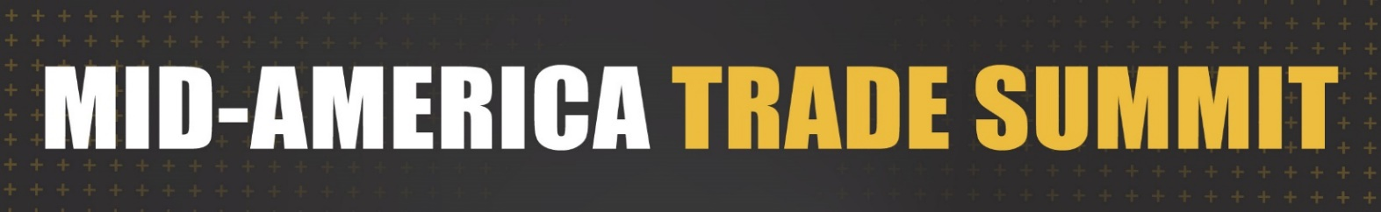
AGENDA

Wednesday, October 7, 2026 – Morning Session (9:00 a.m.-Noon)

8:45 a.m. Informal Networking Opportunity

9:00 a.m. Welcome and Opening Remarks

9:15-10:00 a.m. AI for Exporters – Putting AI to Use in Global Business

AI is changing how companies do business, but where can it make a difference for exporters today? This session will explore how exporters can use AI to improve efficiency, uncover insights, accelerate innovation, and tackle everyday business challenges. Gain practical tips for integrating AI into your operations and competing more effectively in global markets.
Panelists: Mike Strope, President - MSSC (IL)
Arjun Subramaniam, Founder & CEO – Factory Intelligence

Moderator: Drew Reeves, Director of Transformative Technology, Trulaske College of Business

10:00-10:15 a.m. Trade Resource Highlights

10:15-11:00 a.m. Building Your Global Sales Channel – Finding Your Path to Market
Success in international markets starts with choosing the right market-entry strategy and sales channel for your business. Should you sell direct, work with an agent, partner with a distributor, go online or consider another approach? Join experienced business leaders for a candid conversation about evaluating market-entry options, selecting the right sales partners, building strong relationships, and managing performance. Hear firsthand what works, what doesn’t, and the lessons they’ve learned building sales channels around the world.
Panelists: Ray Garvey, Int’l Bus. Dev. Manager, Grasshopper Group (KS)
Matt Jones, Founder, Crease Beast (KS)
Thomas Peace, Director of Sales, Preferred Popcorn (NE)
Moderators: Warren Anderson, Acting State Director, Missouri – USCS-St. Louis
Fernando Bentz, Acting Office Director, USCS – Kansas City

11:00 a.m.-Noon Keynote Presentation: Global Trade in 2026: The Regulatory Shifts Every Business Should be Watching
Global trade is evolving at an unprecedented pace. In this keynote, Jennifer Diaz will examine the latest developments shaping international trade, including tariffs, executive orders, enforcement priorities, USMCA updates, forced labor compliance, and the growing role of AI in customs enforcement.
Presenter: Jennifer Diaz, President, Diaz Trade Law

Noon-1:30 p.m. Lunch Break

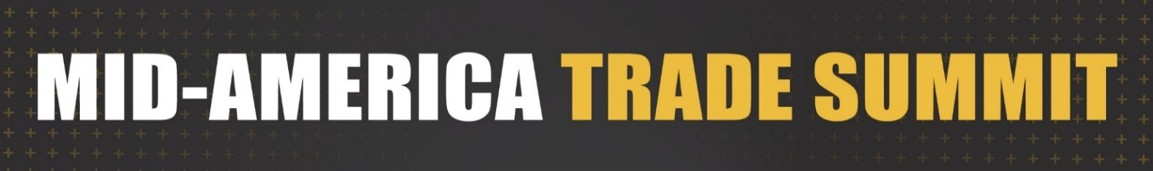
AGENDA

Wednesday, October 7, 2026 – Afternoon Session (1:30-4:00 p.m.)

1:15-1:30 p.m. Informal Networking Opportunity

1:30-2:00 p.m. Recognition of 2026 Outstanding Exporter Honorees

2:00-2:45 p.m. Payment Risk Mitigation: Leveraging Trade Credit Insurance for Global Growth
Looking for a way to protect your international receivables while confidently expanding into new and existing global markets? This session explores how trade credit insurance can help reduce payment risk, safeguard customer payments, strengthen credit management and due diligence, and support sustainable international sales growth.
Presenter: David Clark, Vice President, ARI Global, Inc.

2:45-3:45 p.m. Ask the Global Trade Experts Panel
This session is your chance to hear directly from experienced trade professionals and trade service/assistance providers. They'll share real-world lessons learned, best practices, and strategies that they utilize in their daily interaction with SME’s doing business internationally. Even better - you'll have the opportunity to ask your own questions and receive candid, practical advice from panel members. If you're looking to expand internationally or want to sharpen your exporting know-how, this is the session to join. It's all about connecting, learning from those with expertise & experience, and walking away with insights you can put into action.
Panelists: Caitin Murphy, CEO, Global Gateway Logistics
Dana Watts, Counsel, Diaz Trade Law
Paul Toskin, VP Trade Service Group, Commerce Bank
John Adessi, Business Advisor, Kansas SBDC
Moderator: Tom Dustman, Director of International Sales – Sunnen Products Company & Vice-Chair, National District Export Council

3:45-4:00 p.m. Thanks and Closing Remarks

